variable

d1 : vector from origin to local frame 1 to anchor measured at local frame 1

d2 : vector from origin to local frame 2 to anchor measured at local frame 2

p1 : vector from world origin to local frame 1 origin measured at world frame

p2 : vector from world origin to local frame 2 origin measured at world frame

r1 : quaternion of local frame 1

r2 : quaternion of local frame 2

known variable : d1, p1, p2, r1, r2

variable to calculate : **d2**

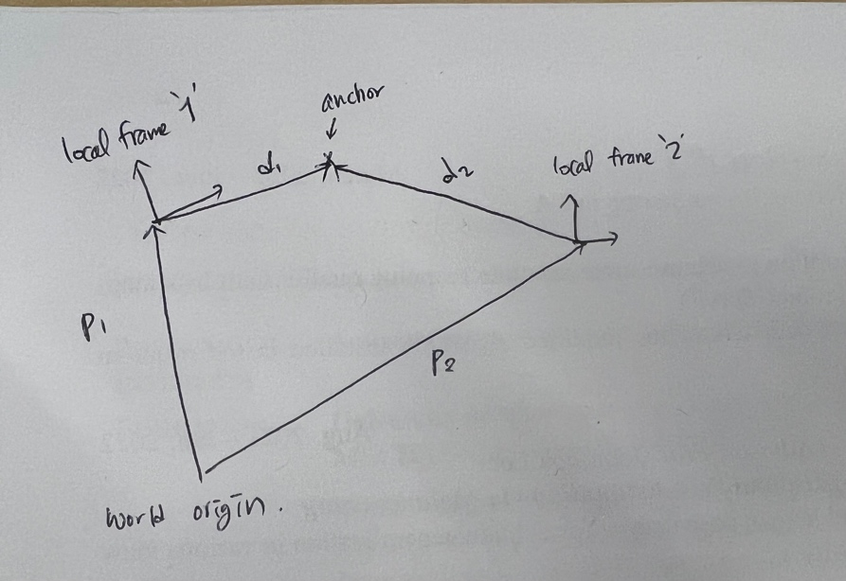

Equation)

R1 = quat2mat(r1)

R2 = quat2mat(r2)

d1_world = matmul( R1.T , d1 ) : distance of vector d1 measured at world frame

let d01 : vector from world origin to anchor point measured at world frame,

d01 = p1+d1_world

let d2_world : distance of vector d2 measured at world frame,

d2 _ world = d01 – p2. -**eq1**

also,

d2_world = matmul( R2.T , d2 ) -**eq2**

by comparing **eq1** and **eq2**,

d01 – p2 = R2.T * d2

so,

d2 = R2 * (d01-p2)

= quat2mat(r2) * ((p1 + R1.T * d1) -p2). **(ans)**